* **DEALERSHIP MANAGEMENT SYSTEM**

|  |  |
| --- | --- |
| Problem Statement | Possible Solution |
| 1. Inventory Management | 1. Implement an automated inventory tracking system. |
| 2. Order Processing Delays | 2. Optimize order workflows with real-time tracking. |
| 3. Inconsistent Data | 3. Use a centralized database with data validation. |
| 4. Sales Tracking Issues | 4. Integrate a robust sales tracking system. |
| 5. Payment and Accounting | 5. Automate financial processes with accounting software. |
| 6. Lack of Real-Time Data | 6. Deploy cloud-based real-time monitoring solutions. |

**Quantitative Research** :

Dealership Management Systems (DMS) reveals mixed user experiences. While it improves operational efficiency and customer service, challenges like system integration and training persist. Users highlight both the benefits and frustrations of adoption. Overall, DMS plays a crucial role in dealership management despite existing limitations.

**Interview question**

1. What was your experience like when learning to use the DMS?
2. Have you experienced any technical issues or downtime with the DMS? How did it impact operations?
3. Does the DMS meet the specific needs of your dealership, or do you find it limiting?
4. How effective is the DMS in providing insights or reports that help in decision-making?
5. What are the biggest frustrations or difficulties you face while using the DMS?
6. Can you describe your experience using the DMS in your daily work?
7. Does the system help you track and manage customer relationships effectively?
8. What improvements would you like to see in the system’s training and documentation?
9. How do you see DMS technology evolving in the future to better meet dealership needs?
10. How would you describe the effect of the DMS on inventory management and stock control?

**Key Insight :**

* **User Experience & Adoption** – Employees highlight ease of use and training quality as key factors in DMS effectiveness. Systems with intuitive interfaces lead to higher adoption rates.
* **Operational Efficiency** – A well-integrated DMS streamlines sales, inventory, and service operations, reducing manual errors and improving workflow efficiency.
* **Challenges & Pain Points** – Common issues include system downtimes, complexity, and a lack of customization, leading to frustration among users.
* **Decision-Making Factors** – Dealerships prioritize scalability, integration with third-party tools, and cost-effectiveness when selecting a DMS.
* **Customer Impact** – A well-functioning DMS enhances customer experience by reducing wait times, ensuring accurate service records, and improving communication.

**Qualitative Research :**

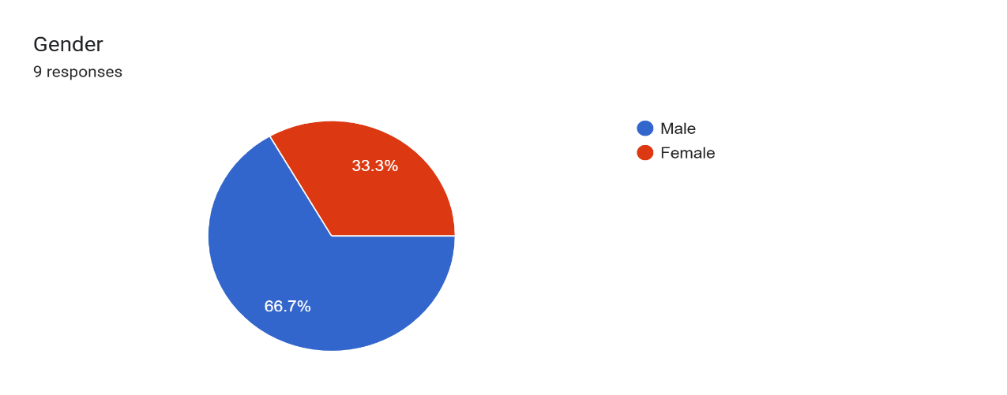

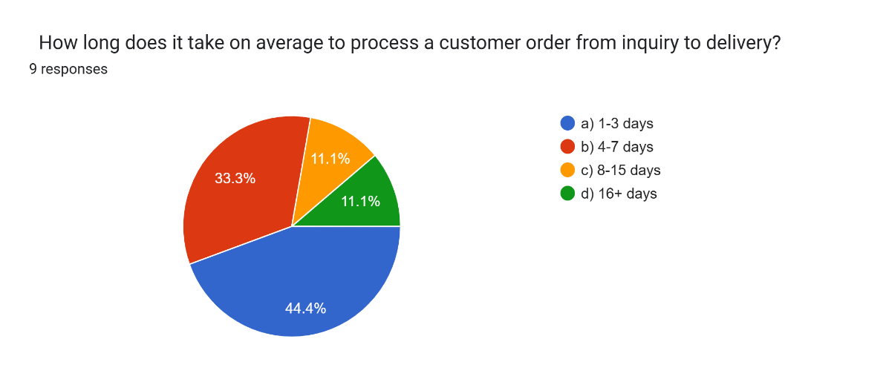

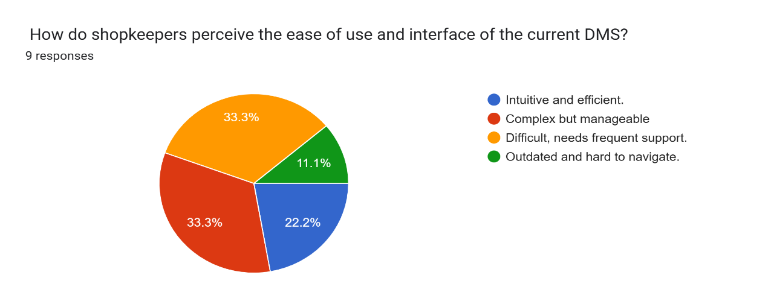

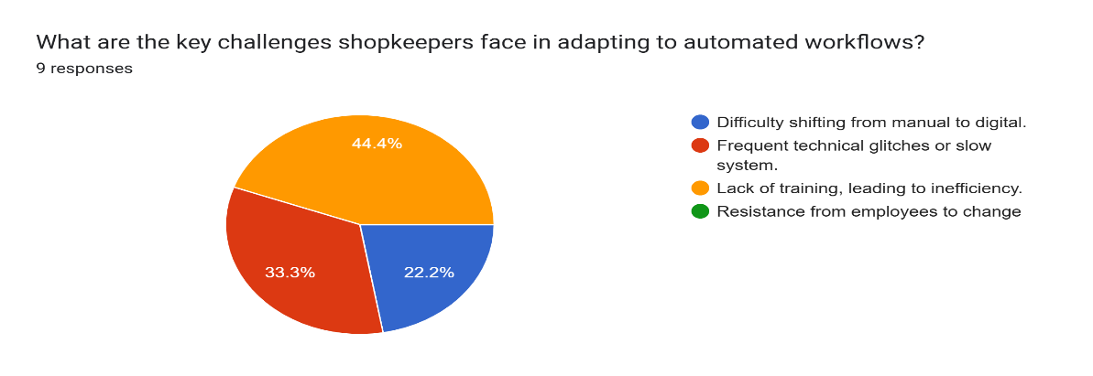

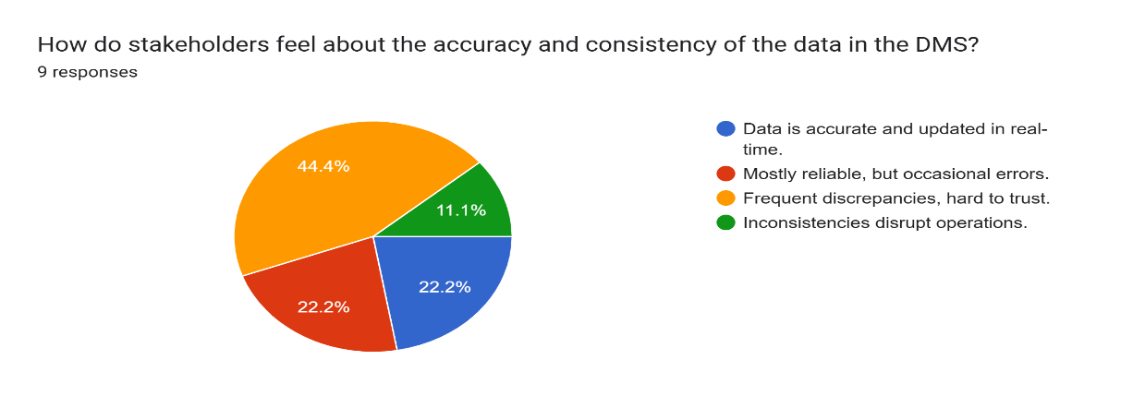

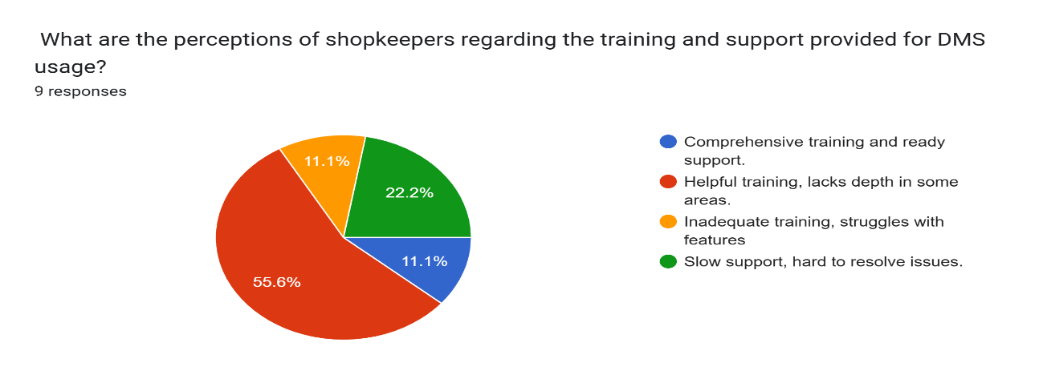

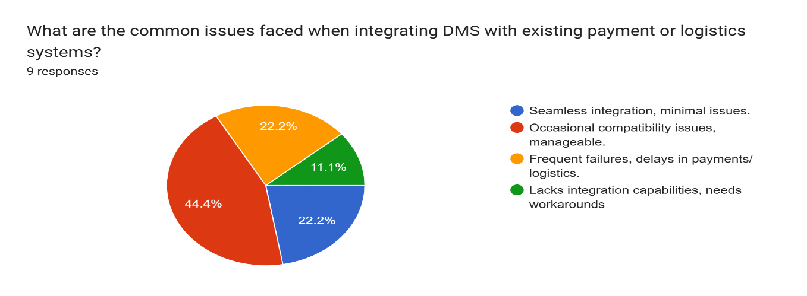

**Brain Storming :**

1. **Centralized Inventory Management**: Real-time stock tracking and error minimization.
2. **Automated Order Processing**: Faster workflows and improved communication between sales and management.
3. **Enhanced Communication**: Tools with notifications and alerts for better coordination.
4. **Improved Customer Service**: Timely order fulfillment and faster response times.
5. **Advanced Reporting**: Analytics for data-driven decisions and strategy optimization, boosting efficiency and profitability.

**Mind Mapping** 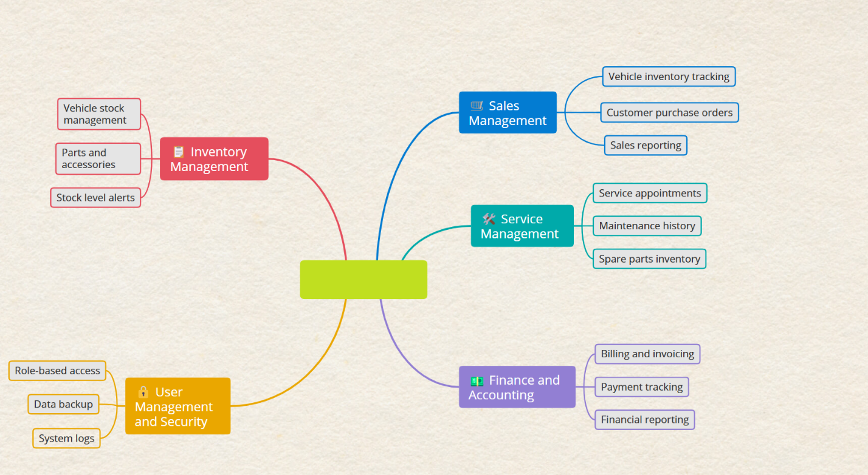

**User Resona :**



**Name : Korim**

**Age: 28**

He lives in Mirpur, Dhaka, a crowded residential area.

Is interested in quantitative research on dealership management systems (DMS), including metrics like inventory accuracy, order fulfillment time, error reduction, sales performance, payment efficiency, stock turnover, customer satisfaction, financial accuracy, operational efficiency, and sales growth.

**Frustration :**

1. Inventory Management Issues
2. Cash Flow Problems
3. Difficulty managing expenses and income, leading to a shortage of working capital for day-to-day operations.
4. Customer Complaints.
5. Handling unsatisfied customers, returns, or disputes can be time-consuming and stressful.
6. Staffing Challenges Dealing with employee turnover, lack of skilled staff, or poor performance can disrupt daily operations.
7. Competition Pressure Facing competition from other local businesses or online stores that offer better deals or more convenience.

**Goal :**

* + Increase Sales : Use promotions, upselling, and new product offerings to boost revenue.
  + Improve Customer Satisfaction: Provide excellent service and resolve complaints quickly.
  + Efficient Inventory Management: Track stock levels to prevent wastage and overstocking.
  + Optimize Profit Margins: Reduce costs, refine pricing, and negotiate better supplier deals.
  + Expand Customer Base: Use marketing, loyalty programs, and partnerships to attract customers.

**EMPATHY MAPPING:**

**Says:**

* + - "The system helps track inventory better."
    - "I wish the interface was simpler and more intuitive."
    - "Customer orders take longer than expected sometimes."

**Thinks:**

* "Will the system help me increase sales by making inventory management easier?"
* "How do I integrate this with my payment system?"
* "I wonder if the system will help reduce mistakes in order fulfillment.

**Does:**

* + - Inputs sales data and inventory updates into the DMS daily.
    - Reviews customer feedback to improve service.
    - Uses reports to assess sales performance and product stock levels.

**Feels:**

* + - Frustrated with occasional technical glitches.
    - Hopeful that the system will improve his efficiency in the long run.
    - Anxious about the learning curve for new features or updates.

**USER JOURNEYMAP**